The United States’ Alaska Buoy Network Expansion

Eric A. Meindl
Chief, NDBC Operations Branch

and

Michael K. Burdette
Oceanographer, NDBC Operations Branch
Manager, Alaska Buoy Project

ABSTRACT

The United States’ (U.S.) National Weather Service (NWS) plans to increase significantly the size of its marine observation network in the North Pacific and Bering Sea. The NWS’ National Data Buoy Center (NDBC) will install and operate at least seven new buoy stations around Alaska by September 2003. The primary purpose of the buoys will be to report marine meteorological observations critical to supporting NWS’ operational mission. The program requirements are discussed and plans to implement and operate the expanded network are provided.

1. INTRODUCTION

The United States’ (U.S.) National Weather Service (NWS) has been funded to expand the network of buoys around Alaska, its largest state. The existing automated network of five moored buoys and seven fixed Coastal-Marine Automated Network (C-MAN) stations is being increased by seven more buoys. NDBC, an organization within NWS’ Office of Operational Systems, has been assigned the lead on this expansion. The project, referred to as the Alaska Buoy Network Expansion (ABNE) will be completed by the end of September 2003. New buoy stations will be placed within 200 kilometers (km) of the coast from southeast Alaska to the western Aleutian Islands.

The marine observation network around Alaska, which covers an area as large as approximately one-third of the entire United States and whose coastline extends nearly 10,000 km, is seriously deficient (Figure 1). In-situ marine observations are available, mostly from unevenly spaced automatic stations and manual ship reports. In spite of a huge number of fishing vessels and a fishing industry extending from southeastern to southwestern Alaska, only two buoys were located within 200 km of the coast prior to summer of 2001. Both were established near Prince William Sound in 1995 in response to the Exxon Valdez disaster several years earlier. They are configured to report wind direction, speed, and gust; barometric pressure; air and sea surface temperature; and sea state every 30 minutes (min). Two other near shore stations (46079 and 46083) were set in summer, 2001, and are the first stations in the ABNE. They report hourly. Elsewhere around Alaska, three moored buoys are offshore in the Bering Sea and Gulf of Alaska; and a C-MAN station is located at Five Fingers Light in southeast Alaska. These have been operating for more than 15 years.

Three C-MAN stations were established in the area between 1995 and 1997. In late 1999, three more C-MAN stations concentrated in Cook Inlet and near the Kenai Peninsula were installed. C-MAN stations report the same data as the buoys, excluding information for sea surface temperature and sea state.

2. BACKGROUND

NWS coordinated with its Alaska Region (AR) headquarters to update its requirements for in-situ marine weather observations. AR performed a quantitative assessment of needs based on input of marine forecasters, boating public, and the U.S. Coast Guard (USCG).

The seven locations identified were, in order of priority (Figure 2):

Fairweather Grounds (58.2N 138.0W)
Barren Islands (59.0N 152.2W)
Central Aleutians (52.0N 172.0W)
Cape Suckling (59.6N 143.7W)
Shelikof Straits (58.0N 154.0W)
Western Aleutians (51.3N 179.1W)
Southwest of Sitka Sound (56.6N 136.2W)

In addition, NDBC, which has operated networks of approximately 70 buoys and 55 C-MAN stations for over a decade, was tasked with coordinating through the USCG with respect to its ability to provide ship support for station service and exchanges. The ability of USCG District 17 (D17), which is responsible for providing ship support for NDBC around Alaska, to add ABNE to its workload is extremely important to keep direct project costs manageable. D17 has provided an average of approximately 23 Cutter days and 6 aircraft days per year to support the existing network and other coinciding mission requirements. The locations selected are expected to increase the D17 Cutter days per year by up to 20, or about 87% above present tasking levels.

3. PROJECT CHALLENGES AND APPROACH

A number of practical challenges faced NDBC when it developed plans for ABNE. These will continue during its execution and long term operation and maintenance after the stations are installed. The most significant challenges included environmental factors affecting the deployment and long term maintenance schedule; required adjustment to the parts inventory; the procurement and fabrication schedule; and the long term maintenance philosophy that would be a compromise between ideal service to the customer and available USCG assets.

3.1 Environmental factors

The marine environment around Alaska (north Pacific and Bering Sea) is one of the most severe in the world; historically, it is the most difficult region for NDBC operations. Buoys are frequently battered by strong winds and high seas from October through April for days, sometimes more than a week at a time. The highest significant wave heights recorded near Alaska by an NDBC buoy were 15.4 m at station 46035 (56.7 N, 177.8 W), in the Bering Sea, and 14.8 m at 46001 (56.3 N, 148.2 W) 250 Km southeast of Kodiak Island. With the exceptions of direct hits by hurricanes, the highest wind speeds at these stations have not been exceeded at any other NDBC station (Table 1). During 2001, extreme weather resulted in the capsizing of a 12-m discus buoy at station 46035, an unprecedented occurrence for that type of buoy when not adrift (Ref. 1), and a rare sinking of a 6-m boat shaped Navy Oceanographic Meteorological Automatic Device (NOMAD) buoy at 46061 following prolonged severe weather (Ref. 2). In spite of the recent loss, the 6-m NOMAD hull was selected for all ABNE stations because it has proven the most survivable hull type among NDBC’s choices.

From a practical standpoint, another advantage is that the NOMAD hull is available for purchase through the U.S. General Services Administration (GSA) schedule. Because it is an available commodity, the procurement process is shortened significantly to less than one year for seven hulls. If a fully competitive process had been required, the time would have been at least doubled. Fortunately, NDBC was able to draw the first two hulls from its inventory for deployment during the first year. At the same time, minor adjustments were made to existing engineering 6-m NOMAD drawings. Literally within the same week that the first prepared hull was shipped by truck from Mississippi to Alaska, the first new hull fabricated specifically for ABNE was received by NDBC at SSC from the manufacturer near New Orleans, Louisiana. The stark difference in appearance and configuration between a brand new hull and one fully prepared for shipment is shown in Figure 3.

3.2 Deployment and maintenance

Close coordination of ABNE with the USCG D17 may have been the most important component of developing the plan. Although its area of responsibility is enormous, D17 has few Buoy Tenders designed for offshore operation; they are stationed in Kodiak, Cordova, Sitka, and Homer. Other ship resources are available to service buoys; however, no others have cranes aboard capable of lifting and setting hulls during exchanges on station. This problem can be overcome to a degree by towing the hulls to and from station; however, given the distances involved, it is not a practical option.

Scheduled maintenance and exchanges will be limited to the months from May through September. Unscheduled maintenance may be arranged during the other seven months, but not exchanges. The ability to accomplish service visits to restore critical measurements will depend on USCG ship availability and, ultimately, weather and sea conditions. Such operations will require careful consideration and excellent long range weather forecasts, since all NDBC buoy technicians are assigned to the industrial facility in Mississippi, several thousands of kilometers away.
After consideration of all factors, a schedule was established to deploy two buoys by September 30, 2001, three more by the same date in 2002, and the final two in 2003 (Ref. 3).

3.3 Inventory to support the project

NDBC received short notice of the ABNE. As a result, NDBC suddenly found itself lacking sufficient numbers of system parts sufficient to support the project, such as mooring components and sensors. The Project Manager was responsible for examining the inventory and identifying what items and their quantities necessary to maintain a 30 percent level of spares for most items. While that level may appear high, a significant portion of that inventory is not at the NDBC facility because some components are in transit to or from a station, or at NDBC awaiting refurbishment or testing.

Hundreds of items were identified that needed to be ordered, from simple things such as nuts, bolts, and 500 pound lead ballast blocks, to navigation lights and radar reflectors, to complex wave sensors and computer processors (referred to as payloads), and a procurement plan was put in place.

4. FUTURE OF ABNE

Subsequent to the initial request, the NWS AR has indicated the network expansion is not sufficient to adequately support its operational mission. They have indicated the need for at least 16 additional buoys and 8 C-MAN fixed stations. Such an expansion will cost $5.4M (U.S.), and Operations & Maintenance (O&M) costs will increase to approximately $1.4M (U.S.) per year. This does not include USCG Cutter requirements which will increase substantially. The initiative is under consideration by the U.S. Congress.

5. CONCLUSION

The U.S. network of moored buoys around Alaska will be increased by seven (7) stations by September 30, 2003. The expansion presents a number of environmental, technical and logistical challenges that must be met in order for the expansion to benefit the NWS operational marine program.

REFERENCES

- Gilhousen, David B., The Capsizing of a 12-M Discus Buoy at 46035, National Data Buoy Center, Sea Worthy October 2001 issue.

- NDBC Technical Document 01-03, The Loss of 6N40, National Data Buoy Center, December, 2001, 83 pp.

- Implementation Plan for the NWS Alaskan Buoy Network Expansion, National Data Buoy Center, Stennis Space Center, Mississippi 39529-6000, June 30, 2001.

 | Peak Wind (m/s) | Pressure (hPa) | Lowest Temp (°C) | Significant Wave Height
46001  (Since 6/72) | 31.1 | 1054.9  943.5 | -14.8 | 14.8
46035  (Since 9/85) | 38.9 | 1050.7  942.5 | -11.6 | 15.4
46006/066  (Since 4/77) | 37.2 | 1044.4  952.1 | -1.6 | 12.9

Table 1. Extreme values of peak wind, atmospheric pressure, minimum air temperature, and greatest significant wave heights measured by moored buoys around Alaska since stations were established.
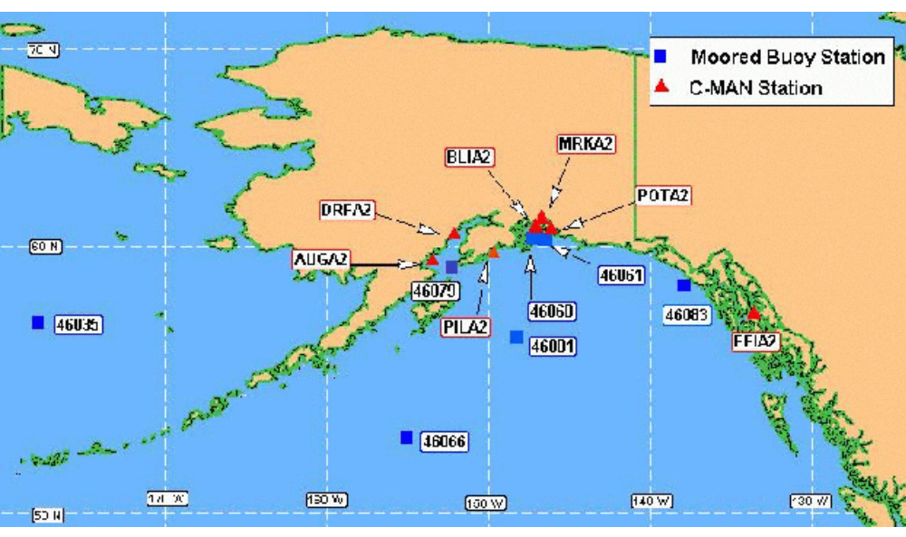

Figure 1. Map showing the location of NDBC moored buoys and Coastal-Marine Automated Network (C-MAN) stations around Alaska. Buoy identifiers are numeric; C-MAN identifiers are alpha-numeric. Buoy stations 46079 and 46083 were placed in summer 2001 and are part of ABNE.

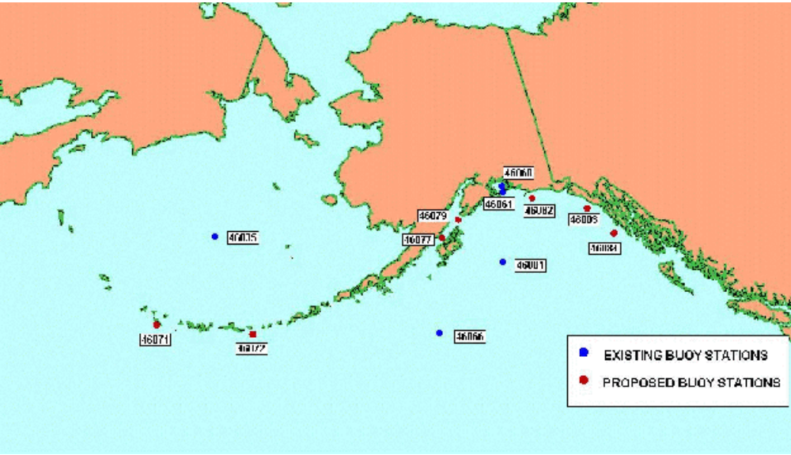
Figure 2. Map showing the location of all NDBC moored buoy locations when ABNE is completed in 2003.

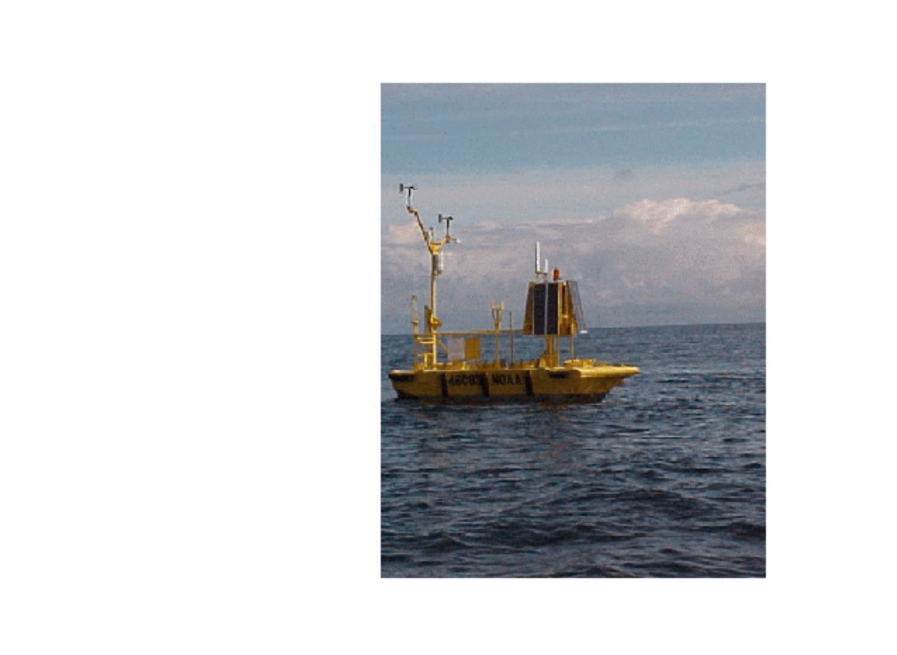
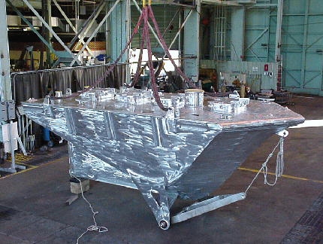
Figure 3. Photo of 6-m NOMAD buoy when received from manufacturer (above) compared to 6-m NOMAD after deployment at Station 46083 (below).

